OMCT E-Bulletin
December 2021

72nd session of the Committee Against Torture

This E-Bulletin is part of the OMCT’s Anti-Torture Programme. The OMCT mobilises and coordinates activities of civil society organisations during the sessions of the United Nations Committee Against Torture (CAT). It facilitates the engagement of civil society by building coalitions, sharing information, ensuring timely and effective report submissions, advising on advocacy opportunities and supporting effective access to the CAT. Find out more about our work on our website.

Table of Contents
Introduction 2
What’s Up 2
OMCT CAT Preparatory Missions 4
OMCT Submissions 5
Summaries of the CAT States Reviews 6
List of Issues Prior to Reporting………………………………………………… 15
Next Sessions 15
Stay Up-to-date 16
We Thank 16

Introduction
In accordance with Article 19 of the Convention Against Torture and Other Cruel, Inhuman or Degrading Treatment or Punishment, State Parties should submit a report to the CAT every four years on new measures taken to implement the Convention. These reports are reviewed in public sessions during which the respective State Party holds a constructive dialogue with the Committee members. Before the consideration of the report, CSOs who have submitted alternative reports can raise their concerns during a private briefing with the CAT. At the end of each session, the CAT publishes its Concluding Observations, which are specific recommendations for each reviewed State and issues for them to follow up on within one year.

What’s Up

After an interruption of two years due to the Covid-19 pandemic, the CAT resumed its in-person country reviews in Geneva, Switzerland. The 72nd session of the CAT, including NGO briefings, was conducted in-person at Palais Wilson and Palais des Nations, except for the review of Bolivia that was conducted in hybrid mode.

For experts Ms Essadia Belmir (member since 2006), Mr Diego Rodriguez-Pinzon (member since 2018) and Mr Peter Vedel Kessing (member since 2021), the 72nd Committee session was their last as their term will end on 31 December 2021. Our gratitude goes to the three of them. We are inspired and encouraged by their commitment to end torture and other ill-treatment, to hold perpetrators accountable and monitor progress on victims’ access to reparation, as well as by their strong support to civil society.

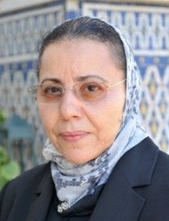

CAT ELECTIONS 2021
The OMCT, together with anti-torture organisations Redress, IRCT, FIACAT, APT, Human Rights Watch and Amnesty International, organised a webinar on 5 October 2021 to meet and greet the eleven nominated candidates to the CAT in the run-up to the elections on 11 October 2021.
The five members (re-) elected to the CAT as of 1 January 2022 for a term of four years are Mr Todd Buchwald (USA), Mr Liu Huawen (China), Ms Maedo Naoka (Japan), Mr Bakhtiyar Tuzmukhamedov (Russian Federation), and Mr Abderrazak Rouwane (Morocco).
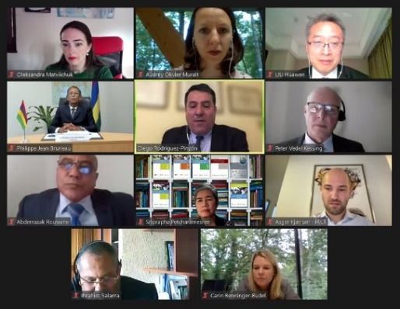

CAT THEMATIC BRIEFING ON MIGRATION AND TORTURE

The OMCT SOS-Torture Working Group on Migration and Torture organised a thematic briefing for the CAT on November 16, 2021. In a one hour-long session, four expert members of the Working Group discussed the main findings of their joint research conducted since 2020 on torture on migration routes in Africa. During the briefing, Mr Moustapha Kebe, from the Réseau Migration et Developpement (REMIDEV) based in Senegal, mapped the different patterns of torture along migration routes in West, Central, East and North Africa. The presentation described a crude reality of violence and extortion by officials at borders, human trafficking, forced prostitution and rape at the hands of criminal gangs. Mr Kevin Mwangi from the Independent Medico-Legal Unit (IMLU) based in Kenya pointed out the gaps in migrants’ access to rehabilitation services in transit and destination countries. The legal framework, the identification process at the borders and personnel have not been adapted or trained to deal with migrant torture survivors.

Ms Maria Teresa Parejo from the Associacion Pro Derechos Humanos in España (APDHE) and Ms Federica Brioschi from Antigone, based in Spain and Italy respectively, contributed to this discussion by bringing the European perspective and highlighting how migration agreements signed by the European Union (EU) and some of its Member States with several African countries have increased the exposure of migrants to torture. Their interventions showed that either human rights obligations are absent from these agreements or they are not fully implemented, and no one is accountable for them.

This discussion emphasised the urgency of mainstreaming the issue of migration and torture in-country reviews, final observations, and recommendations. The CAT members have reaffirmed their engagement in protecting the vulnerability of people on the move from torture and other forms of ill-treatment.

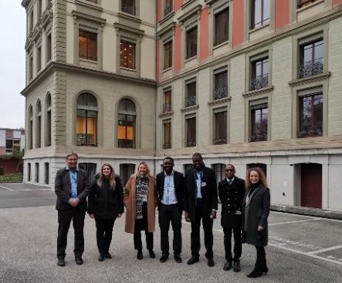

OMCT CAT Preparatory Missions

KYRGYZSTAN

From 18 to 20 October 2021, ahead of the CAT review of Kyrgyzstan, the OMCT organised a preparatory mission headed by Ekaterina Vanslova, an expert of the NGO ‘Committee against Torture’ from Russia. During the mission, CSO representatives and journalists from Kyrgyzstan participated in a workshop on the international obligations of Kyrgyzstan to combat torture and other ill-treatment as well as the various procedures under the United Nations Convention against Torture monitored by the CAT. Moreover, a round table was organised with the support and participation of the Ombudsman Institute of the Kyrgyz Republic, the National Centre for the Prevention of Torture, the OHCHR Regional Office for Central Asia to discuss the alternative report prepared by CSOs for the above-mentioned review. Members of the Kyrgyz governmental delegation, representatives of the Prosecutor General’s Office, the Ministry of Foreign Affairs, the Supreme Court and the Ministry of Internal Affairs also took part in the event.

The Coalition against Torture in Kyrgyzstan, in partnership with the OMCT, organised an online broadcast of the review of Kyrgyzstan, which was attended by representatives of the National Centre for the Prevention of Torture, the Office of the Ombudsman, and CSOs. During the event representatives of State bodies and CSOs had an active exchange of views on the issues that the experts of the CAT had put to the official delegation of Kyrgyzstan during their constructive dialogue.

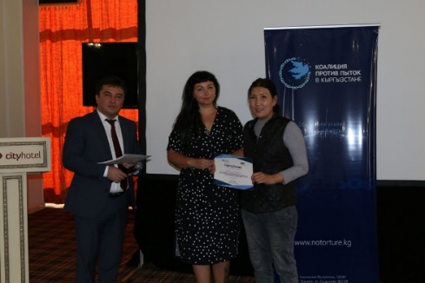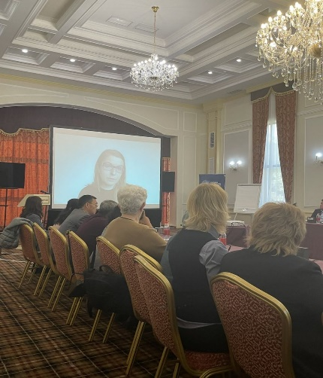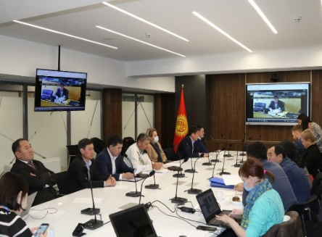

NIGERIA

Ahead of Nigeria’s first review by the Committee Against Torture, in the absence of Nigeria’s initial report, the OMCT organised a mission to Nigeria, Abuja, from 25 September to 2 October 2021 to support the preparation of an alternative joint CSO report for the CAT and advocacy strategy during its session.

In addition to participating in a three days’ preparatory work-shop for CSOs, the OMCT Delegate, Senior Human Rights Advisor for the Africa region Mr Isidore Ngueuleu Djeuga, met with representatives of the Ministry of Justice, the Ministry of Foreign Affairs and the President of the Human Rights Commission of Nigeria. Moreover, a roundtable on excessive use of force and the challenges of Nigeria in complying with the absolute prohibition of torture during counterterrorism activities was organised for CSO representatives, security officers and government representatives.

The OMCT also organised a one-day training for 20 representatives of Nigerian media houses and discussed the implementation of the United Nations Convention Against Torture and the importance of giving visibility to Nigeria’s review by the CAT.

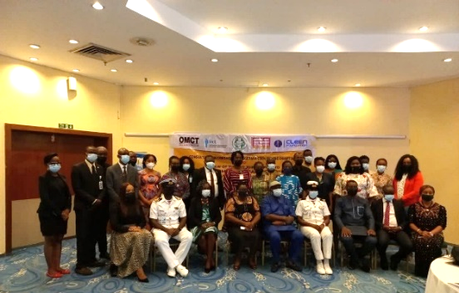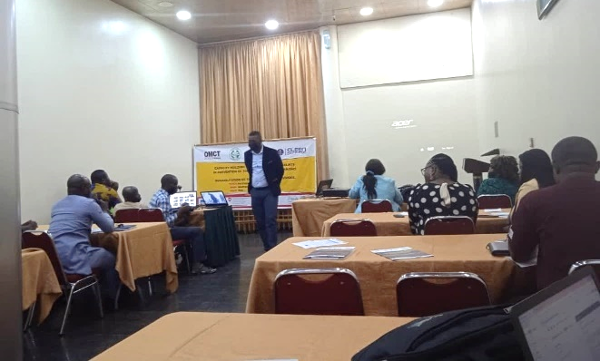

OMCT Submissions

BOLIVIA
The alternative report prepared by a coalition of Bolivian civil society organisations and the OMCT provides an evaluation of Bolivia’s compliance with the recommendations adopted by the CAT at the end of the previous review and analyses the main and systematic deficiencies that allow torture to continue in the country. The report formulates specific recommendations to improve this situation.
During the implementation period of the Committee’s recommendations, the crime of torture has not been adapted in accordance with international instruments. Torture is still used as a method of investigation, intimidation and punishment in detention centres, the army and in the context of protests. Frequent use of pre-trial confinement, overcrowding and the poor conditions in prisons and cases of sexual violence against women committed by police officers in jails in Bolivia constitute cruel and inhumane treatment. Likewise, abortion continues to be criminalised in the country, despite the United Nations treaty bodies' definition according to which forcing people to conceive in certain circumstances is a form of torture.

KYRGYZSTAN

Since the submission of the second report by Kyrgyzstan in November 2013, several steps have been taken by the government to combat torture and impunity, including the introduction of the prohibition of torture and ill-treatment in the national legislation; the limitation of grounds for exemptions from liability for the crime of torture; the implementation of principles of the Istanbul Protocol into national legislation; and the adoption of its first Human Rights Action Plan for 2019-2021. Despite these steps, the practice of torture remains widespread in the country, particularly against detainees, journalists, women, children, ethnic minorities, and other vulnerable groups. Furthermore, serious concerns are expressed regarding the continued campaign aimed at discrediting and intimidating civil society organisations and human rights defenders. The government has still not effectively and promptly investigated the death of human rights defender Azimzhan Askarov in detention in July 2020.

The OMCT jointly with its Coalition against Torture partners in Kyrgyzstan and the Association for Protection of Human Rights in the Criminal Proceedings “ARTICLE 9” have submitted alternative reports on the situation in Kyrgyzstan to the CAT ahead of the CAT review of Kyrgyzstan .

NIGERIA

Twenty years after ratifying the United Nations Convention against Torture in 2001, Nigeria was reviewed for the first time in November 2021. The country has developed a strong legal framework prohibiting torture and other cruel, inhuman and degrading treatment over the past years. Unfortunately, despite these legal steps, the systemic use of torture by security agencies in Nigeria remains widespread. Activities of non-State actors and terrorist groups, together with the Covid-19 pandemic have introduced disturbing dimensions to the issues of torture and accountability mechanisms.

Addressing these issues, a joint alternative report has been submitted to the CAT by the OMCT and 27 civil society organisations committed to the protection of human rights and the fight against torture, including violence against women and the protection of children and migrants in the country, as a result of the above mentioned preparatory workshop.

Summaries of the CAT States Reviews

Bolivia

The 2019-2020 socio-political crisis and impunity for acts of torture

In a hybrid session, the Committee examined the third periodic report of Bolivia and focused on the following five areas: typification of the crime of torture, fundamental legal safeguards, human rights violations during the 2019-2020 crisis, impunity, and gender-based violence.
As in its Concluding Observations in 2013, the Committee urged the State to modify the definition of the crime of torture in Article 295 of the Criminal Code so that it covers all the elements contained in Article 1 of the Convention. The Committee recommended the following measures: i) ensuring the purpose of the criminal conduct is expressly mentioned; ii) including individuals as perpetrators while exercising public functions; iii) reforming penalties according to the seriousness of the crime; iv) eliminating the statute of limitations.
In relation to the fundamental legal safeguards, the Committee remained concerned about the obstacles in the notification of the arrest to a relative or a third party; the lack of immediate access to an independent medical examination, especially in police stations; the absence of an adequate system for registering persons deprived of liberty, among others. The Committee particularly recommended i) strengthening the Plurinational Public Defense Service; ii) establishing a uniform system for the registration of persons deprived of liberty; iii) sanctioning those officials who do not guarantee these legal standards.
The Committee also expressed concern over the serious human rights violations, including racist attacks, during the 2019-2020 socio-political crisis. The Committee asked the State to i) investigate the acts of torture, ill-treatment and excessive use of force and punish the perpetrators, as well as guarantee comprehensive reparation to victims; ii) establish a follow-up mechanism on the recommendations from the Interdisciplinary Group of Independent Experts; iii) regulate with adequate protocols order forces during social protests; iv) investigate and punish attacks against the personnel of the Ombudsman's Office; v) renew the presence of the Office of the United Nations High Commissioner for Human Rights in the State territory.
The Committee also highlighted the lack of autonomy and independence of the Judicial Branch and the Public Ministry, evidenced by the high levels of judicial persecution against political opponents. The Committee recommended the State to i) review its anti-terrorism legislation; ii) carry out a justice reform, increasing training of judges and prosecutors under the Istanbul and Minnesota Protocols; iii) set up a system for the protection and assistance of victims and witnesses of acts of torture deprived of liberty.
The Committee identified gender-based violence as a cross-cutting concern. It is worried about the high incidence of femicide and sexual violence; the narrow definition of rape in the Penal Code that is based on force and excludes the term ‘consent’; the lack of access to safe abortions; the crime of ‘estrupo’ as contemplating lower penalties than those applicable for rape; the victims of human trafficking, among others. The committee issued recommendations aimed at collecting statistical information, reforming the justice system and the penal code, and ensuring comprehensive legal and medical attention for women.
Issues for follow-up:
- Investigation and punishment of violent acts during the 2019-2020 crisis.
- Interdisciplinary Group of Independent Experts follow-up mechanism
- Urgent reform of the justice system
- Activate the Plurinational Council of Rights Humans

Read more: Concluding Observations, meeting summary and webcast.

Kyrgyzstan
Violence against Human Rights Defenders and Journalists
During the consideration of the third periodic report of Kyrgyzstan, the Committee remained deeply concerned about the allegations of torture and ill-treatment of people deprived of their liberty, in particular by law enforcement officials while in police custody. It called on Kyrgyzstan to conduct prompt and independent investigations into all such allegations, including against LGBT people. Concerning the large number of detainees unlawfully held in temporary detention facilities throughout the entire pre-trial period, the Committee underlined that prolonged detention of a person in temporary holding facilities might amount to cruel, inhuman and degrading treatment. It requested the State party to ensure that the period of pre-trial custody does not exceed 48 hours.
The Committee was particularly concerned about the reports that journalists and human rights defenders face threats of intimidation, violence and harassment by State and non-State actors for reporting on corruption. The Committee raised the cases of violence against Mr Aibol Kozhomuratov, a producer at Current Time TV, and the custodial death of human rights defender Azimjan Askarov as instances of human rights violations and the lack of redressal mechanisms for victims of torture.
The Committee recommended the following in relation to the protection of human rights defenders: to i) ensure that human rights defenders and journalists are able to conduct their work and activities freely without fear of reprisals or attack, ii) investigate promptly, thoroughly, independently and impartially all violations committed against them and punish appropriately those found guilty, and iii) review its legislation to allow victims of torture to pursue civil claims for redress, even if the criminal is case is ongoing or had not resulted in a conviction, in line with the Committee’s General Comment No. 3 (2012).

Other recommendations by the Committee to Kyrgyzstan include: i) bringing the content of Article 305(1) of the Criminal Code into conformity with Article 1 of the Convention; ii) strengthening of the Office of the Ombudsman and the provision of greater financial, human and material resources to the National Centre for the Prevention of Torture; iii) ensuring that all detainees have access to fundamental legal safeguards; iv) improvement of conditions within detention centres and prisons, including the provision of medical doctors, psychiatrists and female staff facilities for women; v) thorough investigation of cases of violence against women and human trafficking, especially those committed by State authorities, vi) and ensuring that victims benefit from protection and access to medical, social and legal services and rehabilitation.

Issues for follow-up:
- National Preventive Mechanism.
- Violence against women including bride kidnapping
- Investigation of acts torture and ill-treatment
Read more: Concluding Observations, Meeting Summary and webcast.

Lithuania

Refugees, Asylum-Seekers and Conditions of Detention

During the consideration of the fourth periodic report of Lithuania, the Committee focused in particular on the following issues: refugee and migrant crisis, detention conditions, and investigations in cases of excessive use of force by law enforcement officials.

The Committee expressed its concern about the restrictions imposed on the freedom of movement of refugees, asylum-seekers and undocumented migrants, particularly the mandatory prolonged de facto detention of such persons, including families with children and vulnerable persons. The experts worried about the poor conditions in the accommodation sites for asylum-seekers, refugees and undocumented migrants as those places are overcrowded and lack heating, hot and drinking water, adequate quality of food, and privacy. Access to medical services is limited. Other concerns were: disproportionate use of force, allegations of torture and other ill-treatment by security officials, the lack of measures to prevent and respond to gender-based violence, the lack of information on the asylum procedure, the lack of access to legal assistance and interpreters for refugees and asylum-seekers as well as the reported incidents of collective expulsion of asylum-seekers and the practice of pushback operations.

The Committee recommended the following measures: i) ensure that detention of asylum-seekers, refugees and undocumented migrants encompasses requisite safeguards against unlawful or arbitrary detention; ii) refrain from detention of families with children and vulnerable asylum- seekers; iii) ensure appropriate reception conditions in accommodation sites for asylum-seekers and refugees; iv) implement alternative reception arrangements in local communities; v) conduct a thorough and independent investigation into all instances of alleged torture and ill-treatment; vi) ensure access to information on asylum procedures and legal aid without discrimination and inform them about decisions on their asylum applications in a language they understand; vii) ensure that all asylum-seekers have the right to apply for asylum and to remain on the territory pending the outcomes of the asylum procedure; viii) ensure that asylum requests receive appropriate consideration by the competent authorities and fair treatment; ix) ensure unhindered access of the NHRI, NGOs and journalists to the border zones affected by the regime of emergency situation.

The Committee also expressed concern about the conditions of detention in some prison facilities that continue to fall short of international standards. It is also concerned at reports on excessive use of force by prison staff, including with electric discharge weapons (tasers), large-scale inter-prisoner violence, drug trafficking, the spread of HIV and hepatitis C and the lack of timely access to medical treatment for such diseases.

Other issues addressed by the Committee included: the definition of torture contained in Article 100 (3) of the Criminal Code which which is not fully compliant with article 1 of the Convention, the persisting problem of domestic violence but is still not a separate crime in the Criminal Code; the lack of significant progress in the investigation of the alleged instances of extraordinary rendition, secret detention, torture and ill-treatment under the CIA extraordinary rendition and secret detention program in the State party, in particular in relation to Mr. Abu Zubaydah and Mr. Mustafa Ahmed al-Hawsawi; and the absence of comprehensive statistical data in cases of torture and ill-treatment by law enforcement and prison personnel, or on trafficking and domestic and sexual violence, and on means of redress; and the lack of information regarding the training programs for state officials.

Issues for follow-up:
- refugee and migrant crisis
- conditions of detention
- prompt thorough and impartial investigations
Read more: Concluding Observations, Meeting Summary and webcast.

Nigeria
Police brutality and Prolonged and Arbitrary detention

The Committee considered implementation of the Convention against Torture in Nigeria in the absence of an initial State Report which was due since 2002.

The Committee noted that the 2017 anti-torture act is still not fully compliant with the Convention and recommended the Nigerian State to bring the definition of torture in line with Article 1 of the Convention and exclude torture from the scope of amnesty and pardon provisions. The Committee expressed concern at reports of excessive use of force, including lethal force by shooting leading to extrajudicial killings, during arrests or policing the demonstrations. It also expressed its concerns about the growing militarization of policing activities through joint operations. It noted the steps taken by Nigeria to reform the police and investigate allegations of torture and other ill-treatment, arbitrary arrests and detentions, and extrajudicial killings by the Special Anti-Robbery Squad (SARS) of the Nigeria Police Force. It recommended that the State party make the findings public, prosecute those responsible and redress victims, and train law enforcement and security forces personnel on the prohibition of torture and use of force

The Committee expressed concerns that around 72 per cent of the prison population is still awaiting trial due to prolonged and arbitrary detention including of vulnerable groups. The Committee recommended to bring an end to and investigate arbitrary detentions and assaults against persons with disabilities, drug users and LGBTI persons. It also requested to ensure that all detainees and arrested persons have access to free legal aid, medical services and other legal safeguards, and the provision of human and financial resources to the Legal Aid Council. The issue of chronic overcrowding in detention facilities, especially in the context of Covid-19 was also raised and the Committee required the improvement of material conditions in prisons and correctional facilities including access to food, running water, ventilation, medical and psychiatric services.

The Committee was equally concerned at the numerous allegations of extrajudicial killings, torture, enforced disappearances and sexual violence by the military in the course of the security operations. The State party should ensure the safety and security of persons affected by conflicts by increasing the transparency of investigations into alleged human rights violations by state non-state actors during counter-terrorism operations; as well as prevent the use of child soldiers in the military.

The Committee was alarmed by the allegations of ongoing sexual and gender-based violence in the State-run camps for internally displaced people, as well as by the continued practice of female genital mutilation and the high rate of maternal mortality, often resulting from rape. The Committee urged the State party to step up its efforts to combat all forms of sexual and gender-based violence and to protect internally displaced persons, especially women and girls. It further recommended establishing rehabilitation programmes for victims of torture and ill-treatment, in cooperation with specialized civil society organisations.
Other recommendations included: i) making the declarations under Articles 21 and 22 of the Convention and ratifying core United Nations human rights treaties; ii) public dissemination of the report submitted to the Committee and the Concluding Observations adopted through official websites, the media and NGOs in appropriate languages; iii) submission of the second periodic state party report for Nigeria by December 3, 2025 under the provisions of Article 19 of the Convention.

Issues for follow-up:
- allegations of torture, ill-treatment, arbitrary detention and excessive use of force, in
particular by SARS
- pretrial detention and overcrowding
- the national preventive mechanism
- gender-based violence

Read more: Concluding Observations, Meeting Summary and webcast.

Serbia
Conditions of Arrest, Pre-trial Detention and Torture during Covid-19

During the consideration of the third periodic report of Serbia, the Committee mainly focused on: conditions of detention; fundamental legal safeguards for detainees; impunity for acts of torture and ill-treatment; the asylum system and non-refoulment; treatment of persons in social care and psychiatric institutions and attacks on journalists and human rights defenders.

The Committee expressed its concern regarding the notable reduction in the number of visits carried out by the National Preventive Mechanism (Ombudsman) especially within police detention units, even before the Covid-19 pandemic. Committee experts reminded Serbia that the independent monitoring of places of detention by the Ombudsman and human rights NGOs is crucial. Indeed, the perceived lack of trust by civil society organisations formerly cooperating with the mechanism is worrying. What is also concerning is the fact that the legal framework guaranteeing legal safeguards for detainees is not effectively implemented. For example, there are reports about police officers being present during medical examinations and about medical professionals who fail to document traces of torture and ill-treatment.

Inadequate health care services, particularly psychiatric treatments, in prisons was also an issue of concern. In this regard, the Committee recommended measures including to improve the quality of health services provided to inmates; conduct prompt medical screening upon entry into detention facilities in order to detect and prevent the spread of infectious diseases, including Covid-19; recruit more qualified medical doctors, including psychiatrists; appropriately maintain medical files and registers, including those used for recording injuries; ensure that medical reports of injuries indicating ill-treatment are sent without delay to the independent mechanism responsible for carrying out a thorough examination and investigation; take into account the lessons learned from the Covid-19 pandemic and intensify its efforts to significantly reduce prison overcrowding, by making greater use of non-custodial measures; improve the remuneration and working conditions and increase the number of prison staff.

The Committee also expressed serious concern about the inadequate efforts made to investigate criminal complaints lodged against police officers, prison staff and other state agents. The Committee experts thus recommended to Serbia to : i) ensure that all complaints of torture and ill-treatment are promptly investigated in an impartial manner by an independent body; ii) ensure that the authorities launch investigations whenever there are reasonable grounds to believe that an act of torture or ill-treatment has been committed; iii) ensure that suspected perpetrators are suspended from duty immediately for the duration of the investigation; iv) ensure that both the crime of torture and the attempt to commit such a crime are punishable with appropriate penalties that are commensurate with the gravity of their nature; v) compile and publish comprehensive disaggregated statistical information relevant to all complaints and reports received of torture or ill-treatment.

Moreover, the Committee was worried about the repeated attacks, harassment, intimidation, arbitrary arrest, and detention of journalists and human rights defenders. The Committee therefore urged Serbia to adopt and implement a public policy for their protection and to examine the causes for this unprecedented violence.

When it comes to the treatment of persons in social care and psychiatric institutions, the situation of women and children with disabilities was particularly alarming as they are exposed to high levels of violence and abuse without any prevention or protection measures. In addition, the CAT was of the view that those children are living in poor conditions with inadequate access to health care, education, and rehabilitation.

Other issues addressed by the Committee included: the definition of torture, the failure of the State party to provide with information of persons convicted under counterterrorism legislation, the political influence on judicial appointments, gender-based and domestic violence, redress and compensation for victims of serious crimes, the lack of international judicial cooperation, juvenile justice, the introduction of life sentence in the Criminal Code, and the asylum system and non-refoulement.

Issues for follow-up:

- definition of torture
- independence of the National Human Rights Institution
- impunity for acts of torture and ill-treatment

Read more: Concluding Observations, meeting summary and webcast.

Sweden
Conditions of Detention and Torture against Minors
During the examination of the eighth periodic report of Sweden, the Committee mainly focused on the following five areas: the criminalization of torture and the statute of limitations; fundamental legal safeguards; the imposition of isolation in detention; the investigation of acts of torture; and the use of coercive and intrusive measures in psychiatric hospitals.
As in its Concluding Observations in 2014, the Committee remained concerned that the crime of torture crime has still not been incorporated into domestic legislation and that the Swedish Government understands that the Convention does not impose so due to its legal framework. The Committee recommends promptly defining and criminalizing torture in the legislation as a distinct crime in accordance with articles 1 and 4 of the Convention.
The Committee was also concerned that persons deprived of their liberty are not always afforded all fundamental legal safeguards from the very outset of deprivation of liberty such as the rights to access to a lawyer, to independent medical examination and to notify a relative or a person of their choice. Furthermore, the Committee noted that pre-trial detention is frequent in Sweden and its application increased by 5% between 2014 to 2017. The Committee called on the State to i) consider alternative measures to the use of pre-trial detention; ii) introduce a systematic data collection on the use of restraints/coercive measures used in prisons and pre-detention; iii) continue its efforts to assess the use of pre-trial detention.
The Committee was worried that solitary confinement, including against minors, is still a continuous restriction in the practice. The Committee asked the State to i) use restrictions on remand prisoners only as an exceptional measure based on concrete individual grounds; ii) abolish the use of solitary confinement for minors; iii) carry out thorough investigations of incidents of suicide or suicide attempts and ascertain whether there is a link with the use of measures of physical restraint or solitary confinement.
Another preoccupation of the Committee was the perceived lack of independence of the Special Investigation Department, established in 2015 as an independent body within the Police Authority, with the mandate to independently conduct investigative work in cases of allegations of ill-treatment and excessive use of force by police officials. The Committee urged the State to review possible changes that could be made to address any perceived lack of independence considering its linkages with the Police Authority.
The Committee pointed out that young people in residential care are exposed to unjustified violence by staff, including children restrained for long periods. It is reported that staff are not sufficiently trained and children suffer physical and mental harm. The Committee requested the State to i) use restraints and solitary confinement as a measure of last resort, for the shortest possible time and under strict medical supervision; ii) ensure ongoing monitoring of the conditions in psychiatric institutions; iii) continue to train all medical and non-medical staff on methods of non-coercive care.
Issues for follow-up:
- Definition and criminalisation of the crime of torture
- Restrictions in detention centres, including solitary confinement
- Nonrefoulement of torture victims in deportation proceedings

Read more: Concluding Observations, Meeting Summary and webcast.

List of Issues Prior to Reporting

At its 72nd session, under the optional simplified reporting procedure, the Committee adopted the Lists of Issues for the following five countries: Canada, Guatemala, the Netherlands, Peru and Saudi Arabia.

Next Sessions

73rd session of the CAT
19 April – 13 May 2022

- Consideration of the State Party reports Cuba, Iceland, Kenya, Montenegro, United Arab Emirates, Uruguay.

The deadline for CSO submissions for the State report reviews at the 73rd session is 18 March 2022.

- List of Issues Prior to Reporting (LOIPR) to be adopted at the 73rd session are Benin, Democratic Republic of the Congo, Germany, Greece, Mexico, Poland, South Africa, Togo, United Kingdom of Great Britain and Northern Ireland

The deadline for CSO submissions for the adoption of the LOIPR at the 73rd session is 24 January 2022.

74th session of the CAT
12 July – 29 July 2022

- State reviews of Iraq, Nicaragua, State of Palestine, Ukraine.

Stay Up-to-date

OMCT Blog

Our blog aims to provide greater awareness of the anti-torture work of the OMCT and its partners around the world, the United Nations Convention against Torture and other Cruel, Inhuman or Degrading Treatment or Punishment and its monitoring Committee, the CAT, to build a larger anti-torture movement, increase CAT’s visibility, and to intensify CSO mobilisation around the CAT.

The OMCT invites and encourages CSOs, experts, academics, journalists and other stakeholders to share their experiences in fostering the implementation of the United Nations Convention against Torture, their experiences with the CAT and other anti-torture initiatives anywhere in the world by submitting an article for the blog. Please contact cbb@omct.org for more information.

Live Webcast of the CAT sessions

During the sessions, the live stream is available at webtv.un.org. Sessions are also archived and can be viewed later.

Follow us

We Thank
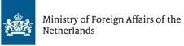
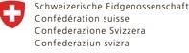
This E-Bulletin has been produced with the financial assistance of the European Union, the Ministry of Foreign Affairs of the Netherlands, the Swiss Federal Department of Foreign Affairs, and Irish Aid. The contents of this document are the sole responsibility of the OMCT and can under no circumstance be regarded as reflecting the positions of the European Union, the Ministry of Foreign Affairs of the Netherlands, the Swiss Federal Department of Foreign Affairs, or Irish Aid.

