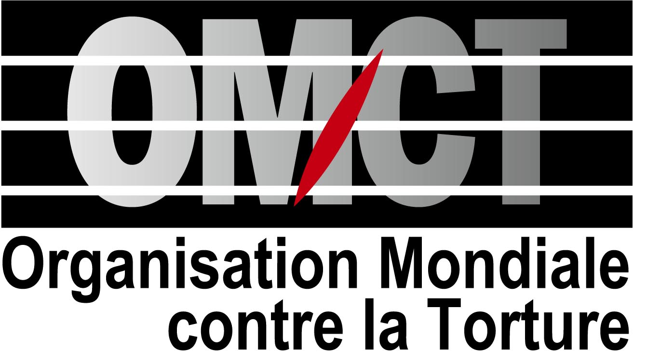

National and International NGOs strongly condemn
the use of force against civilians by Uzbek authorities

Geneva / Tashkent – May 19, 2005 - The Legal Aid Society of Uzbekistan (LAS), the Center for Democratic Initiatives of Andijan, the Center for Human Rights Initiatives of Samarkand, and the World Organisation Against Torture (OMCT) and its European Office, express their deepest concerns about the disproportionate use of force against civilians, on May 13, 2005, during peaceful demonstrations in Andijan, Uzbekistan. This disproportionate use of force resulted in the killing of hundreds of civilians including women and children.

The official sources indicate that 169 people were killed. However, according to the reports from NGOs in Andijan more than 500 persons were killed, and according to the unregistered oppositional political party “Ozod Dehkonlar” at least 745 civilians have perished, including women and children. This number is very likely to rise. “We believe that this is to be considered as disproportionate use of force against peaceful demonstrators and massive summary executions of hundreds of people” said Nozima Kamalova from the Legal Aid Society of Uzbekistan. To date, many of the bodies are kept in an unknown place and relatives are not authorised access to them. Moreover, there are also concerns about the right to fair trial of the 81 persons officially arrested during these events.

President Islam Karimov described these events as a “real terrorist act”, declaring that “during the operation only criminals were killed”. He also denied allegations that he ordered law enforcement personnel to shoot at the peaceful demonstration. “Uzbekistan authorities have always tried to justify their massive human rights violations by using the rhetoric of the war against terror and the national security; and again hundreds of innocent have paid with their lives as they were peacefully demonstrating”, added Eric Sottas, Director of OMCT.

“Considering the human rights situation in Uzbekistan and failure by the government to follow-up and implement recommendations from the United Nations Treaty bodies and those from the Special Rapporteur on Torture, it is vital that any inquiry into these events be international, be prompt and above all independent. Ideally within the framework of the United Nations” said Dilshod Tillahodjaev from Center for Democratic Initiatives, an NGO based in Andijan.

Following the violent repressions of the demonstrations, refugees have been arriving steadily in Kyrgyzstan. Most of them are relatives of the released prisoners, who fled due to the fear of retaliation by the Uzbek authorities. According to Miroslav Niyazov, head of the Kyrgyz Security Council, more than 540 persons have requested asylum to the Kyrgyz authorities and are hosted in camps next to the border with Uzbekistan. Moreover, according to the information received, at least thousands of persons have crossed the Kyrgyz border seeking protection, and 15 of them have been refused access to the camps and returned to Uzbek security forces. The Uzbek Government has proposed to the Kyrgyz authorities to pay for the settlement of the refugees until they can take them back. “It is feared that these refugees will be extradited to Uzbekistan without proper examination of their situation, while some of them might face arbitrary detention, torture or ill-treatment by the Uzbek law enforcement agents” warned Samad Kurbanov from the Center for Human Rights Initiatives of Samarkand.

Background Information:

Recently, 23 businessmen were arrested under the charges of anti-constitutional activities (article 159 of the Criminal Code) and for belonging to an illegal religious group (article 242 of the Criminal Code) for their activity of providing charitable assistance to the families of prisoners. Dozens of people protested in front of the court building while the case was revised by the court. The day before the verdict was due, during the night of May 12 to 13, 2005, a group of unknown people attacked the military base in Andijan and released the prisoners including these 23 businessmen. They occupied a building of the local administration in Andijan and took some members of staff as hostages. There is no information about their precise requests, except that they called for negotiations with the government. In the meantime, on May 13, thousands of civilians, including women and children, gathered around the building in order to prevent access to and assault of the building by military forces. According to the information received from local NGOs, local administrators had started negotiations with the rebels when the order was given to shoot at the peaceful demonstrators.

Related information:

Alternative report on Human Rights in Uzbekistan submitted to the Human Rights Committee on March 2005:
http://www.omct.org/pdf/procedures/2005/s_violence_uzbekistan_2_2005_eng.pdf

Joined press release : “NGOs welcome the UN Human Rights Committee’s concluding observations on Uzbekistan and ask for their full and prompt implementation”, April 26, 2005:
http://www.omct.org/pdf/procedures/2005/press_release_hrcrecomm_Uzbe.pdf

Contact:

- Legal Aid Society of Uzbekistan: Nozima Kamalova, +998.712.76.86.02 – email: nozima@freenet.uz
- Center for Democratic Initiatives of Andijan: Dilshod Tillahodjaev, +998.742.24.10.64
- Center for Human Rights Initiatives of Samarkand: Samad Kurbanov, +998.662.35.38.63
- World Organisation Against Torture (OMCT): Patrick Mutzenberg: +41.22.809.49.39 – email : pm@omct.org
- OMCT-Europe (World Organisation Against Torture – European office): Laëtitia Sédou: +32 2. 218.37.19 – email : l.sedou@euro.omct.org

